TECHNOCRATS ROBOTICS

SUMMER TASK – 1



TASK 1 - INSTRUMENTS

BY – RUDRA PATIL

MULTIMETER FUNCTIONALITY

Part 1 – Different Modes of Operation and overall function

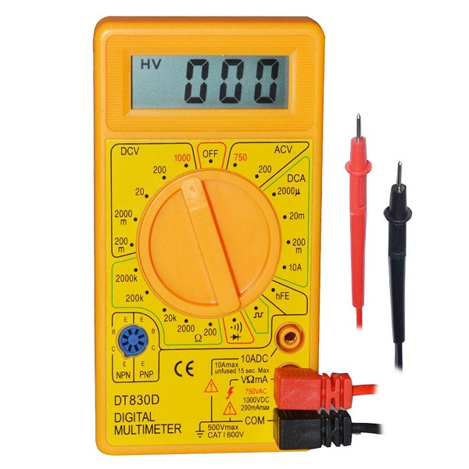

Whenever we have to troubleshoot any circuit or test any component the first instrument that comes in our mind is the multimeter. It is an effective tool in troubleshooting because we can set the multimeter to read the voltage, current, resistance and we can also use it to test for any discontinuity in the wire if there is any.

# PORTS:-

The multimeter as we can see the image has 3 ports. There are 2 probes which we have to connect. The black probe(negative probe) is connected to COM port by convention and for testing we put the red probe (positive probe) in V and R port which can be used to calculate voltage and resistance but if we wish to measure current, we use the 10A port ( topmost port in the image ).

COMPONENTS OF A MULTIMETER :

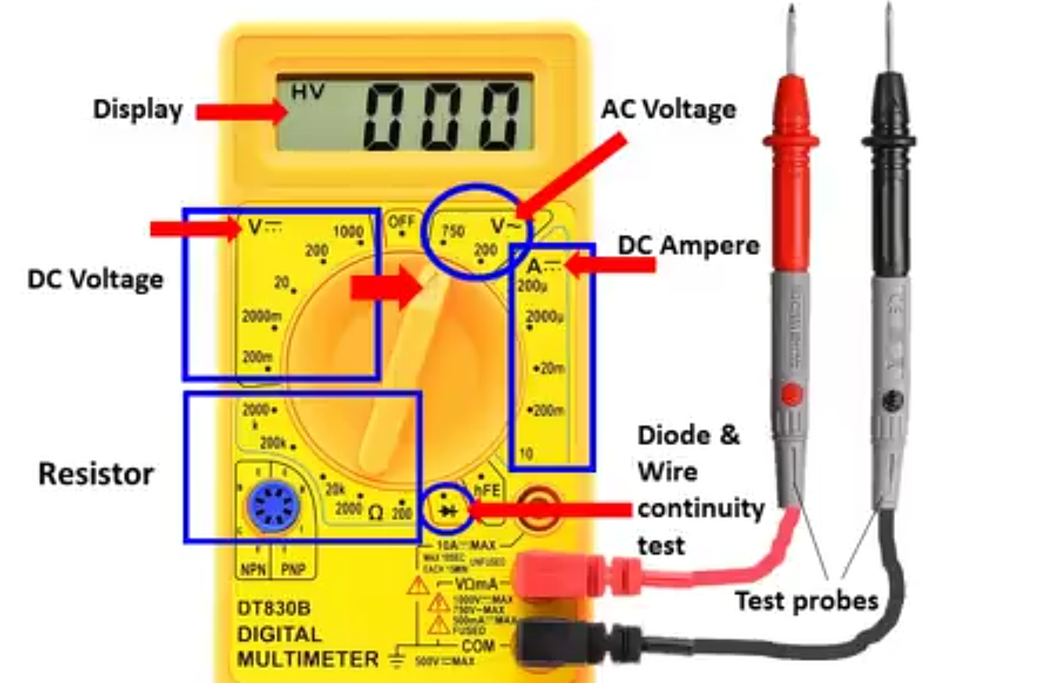

Voltage Measurement:-

The knob of the multimeter has to be pointed in the region where there is the setting to measure the DC Voltage. It is represented by the following:

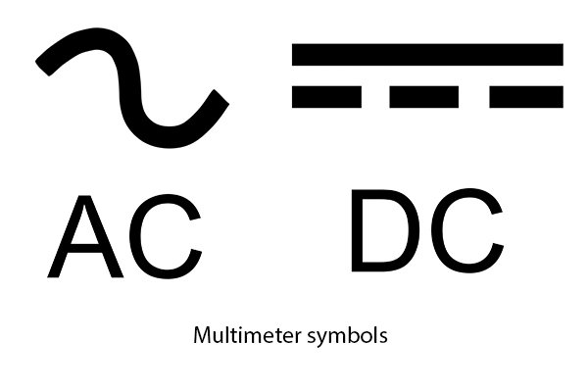

These signs represent the symbol which is seen on the multi meter. DC Voltage is represented by ( V followed by the DC Symbol in the image ), A set of parallel lines where one is bold other is dotted.

After we adjust the knob we have to set a range below which we have to measure. The steps in the ranges is of the form ( 200m, 2000m, 20, 200, 1000)(generally)…It varies in different multi meter. If I set my knob to 20, it means I can measure the DC Voltage of all values up to 20V DC supply.

If we select a setting which is very low than the actual value it will simply display 1 or O.L (overloaded) on the display. And if it is higher than the actual value it will show 0.0 on the display.

If we interchange the probes, the reading becomes negative in value but magnitude is same, only sign changes.

Similarly for measuring AC voltage we can put the probes of multimeter in the terminals of the voltmeter, we can the probes in any terminal of the socket where we will connect the multimeter because in AC it changes value from positive to negative in every cycle of AC waveform. We must choose an appropriate range in AC Voltage to measure the voltage.

# Image result for current measurement in multimeter

# Current Measurements:-

Measuring current in multi meter is similar to that of an ammeter where we cause a breakage in the circuit and measure the current in the multi meter. The selection probe will have values ranging from a few mA to 10Amp. We should know the approximate value which we might get and adjust the selection knob according to the reading in order to get a good value on the LCD display without any error signs. We have to change the ports of the probes of the multimeter from mAV(which we use to calculate voltage) to A(used to calculate large currents).

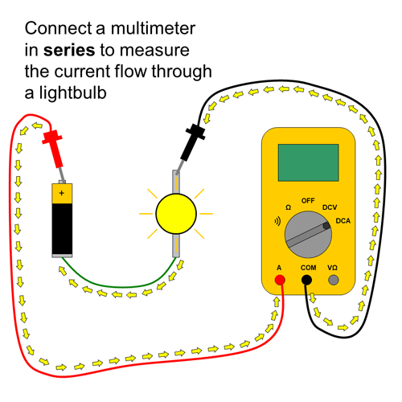

# CONTINUITY:

Continuity is a simple yet useful feature which we use to check for continuous connections in the wires and ensure that there is no discontinuity in between. The symbol on multimeter for checking continuity is shown in the below image. We hear a beep sound if continuity exists and no sound if continuity does not exists.

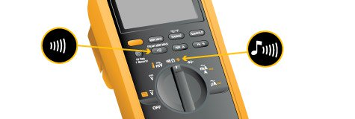

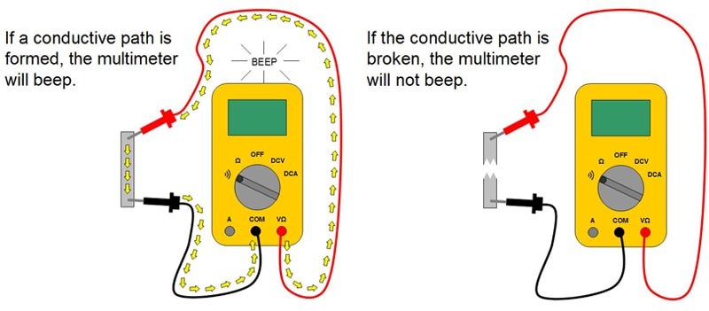

# Measuring Resistance:

Take the resistors out and separately test it in the multimeter by selecting the appropriate range on the selection knob of the multimeter. The multimeter will send some current across the resistor and find its value using ohms law.

If multi meter shows OL or 1 it means we have to adjust to a higher mode of measurement.

If multi meter shows 0.00, we need to adjust to a lower mode of measurement.

# DIODE CHECK:

Similar to resistor, take separately the diode , move the knob to the diode symbol and connect COM to cathode(with white stripe) of diode while Positive(RED) probe to anode then it shows the Diode Voltage, if opposite connections are given , then overload occurs and “1” is displayed.

The most feasible multimeter in the market is the one shown below:-

It is priced at Rs.175 on Amazon and offers all the basic functionality that a multi meter has to offer. It does not have a top notch build quality but the price to functionality ratio is pretty good.

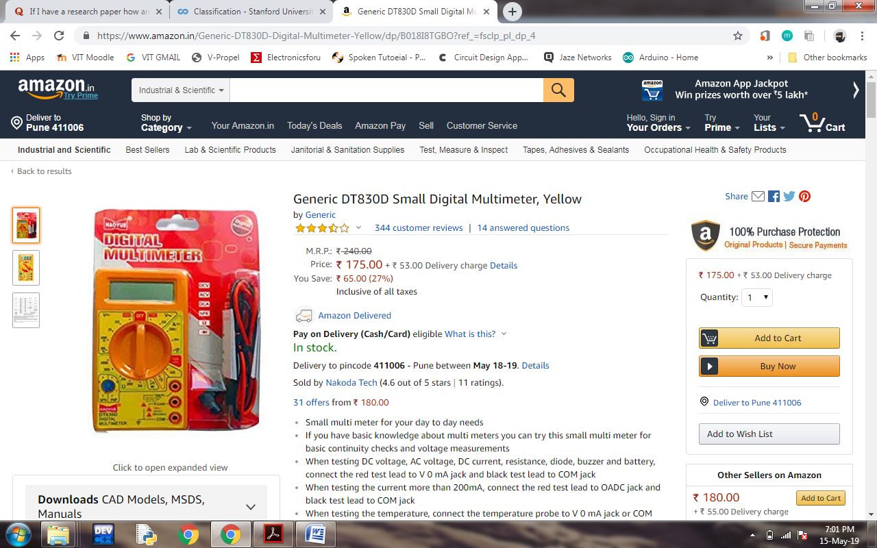

CLAMPMETER

How does it look like?

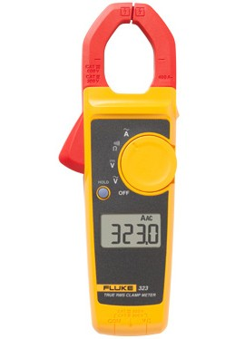

What is it used for?

A clamp meter is a device which we use to measure current but unlike a normal multi meter we use clamp meter because it does not have to be insterted in the line that is carrying the current. In a multi meter you would have to connect it in series with the circuit which is not always a feasible option, so we use clamp meter to directly measure current.

How does it calculate current?

As we know that an current carrying conductor produces an electric field around itself. The jaws of the clamp meter are made of ferrite iron which can detect and measure the magnetic field around the conductor as the current flows.

How to measure?

Choose the wire through which you want to measure the current. Then pass this wire through a loop or the clamp of the clamp meter. Soon we get a reading on the LCD Display of the clamp meter, that value will be the current flowing through the wire.

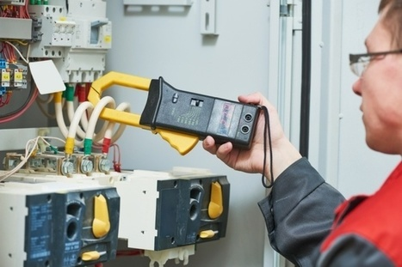

What are different types of Clamp meters?

1. Current transformer clamp meters: measure only AC Current

2. Hall Effect clamp meters: measure both AC and DC current.

3. Flexible clamp meters:  measures AC only and used good for measuring in tight spaces.

TACHOMETER

How does it look like?

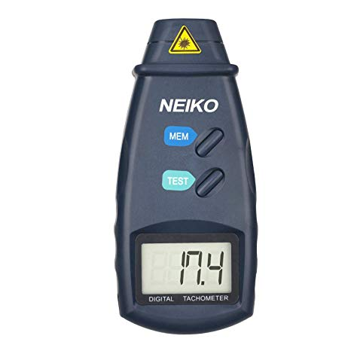

What is it used for?

Tachometer is a device used for measuring RPM (Revolutions per minute ) of a an engine or a motor wheel. The results can be calibrated for an analog scale as used in bikes or can be calibrated to a digital scale for other purposes.

How is RPM Calculated?

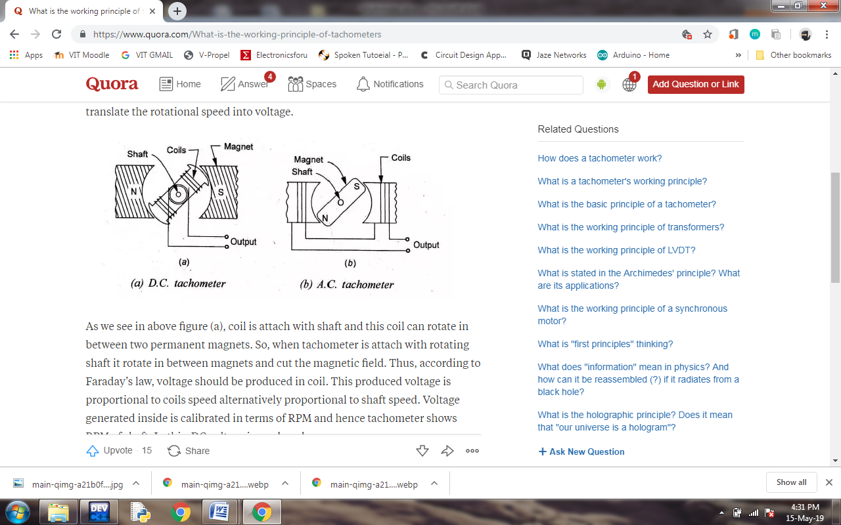

A coil is connected to a shaft between the poles of which rotate as per the motor. There is a magnetic field in between the two poles and thus a magnetic field is induces voltage in the rotating coil which is in accordance to Faraday’s law. This produced voltage is proportional to the speed of the rotating coil. The calibration is done on a analog scale for our bikes and can be put up on a digital scale in terms of speed based on the RPM.

What are the types of tacometers?

1. Contact Type – As explained above uses contact between coil and magnets
2. Non-Contact Type – Uses Infrared Light but the surface of the rotating object requires contrast in color or luster. The infrared light hits the objects and reflects back and detects the change in frequency. The frequency change per unit time gives the speed.

DIGITAL STORAGE OSCILLOSCOPE

Digital Storage Oscilloscopes is an instrument which we use to display and analyze waveform of electronic signals. The device draws a graph of the instantaneous voltage and is shown in time domain. After seeing the signals on a CRO display we get to know about the noise, harmonics, time period, and wave characteristics. A digital oscilloscope takes input as a physical voltage signals and converts it into digital data and uses its memory to store the data for displaying it on the screen.

How do they look?

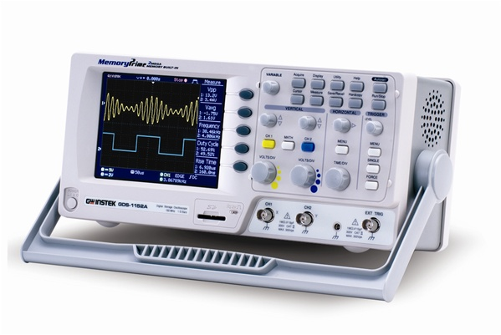

Advantages of DSO:-

1. It is more advanced than a CRO, in terms of providing lot more options to experiment on waveforms.
2. It has more in-built features to automatically calculate time period etc, without having to measure with a scaled graphical output. It reduces chances of error.
3. DSO is less complex than CRO
4. We can store the output waveforms and save them in an external memory like USB Drives

Probable uses of DSO in robotics:-

1. It can represent data from multiple channels in a neat and laid-out manner
2. Data can be copied on USB for further reference.
3. Testing of Sensors
4. Lot of Design and testing engineers use DSO for their work.
5. Performs Mathematical operations on signal output as per requirements
6. Filters out Noise